MIDTERM EXAMINATION
Fall 2009
MTH101- Calculus And Analytical Geometry

Question No: 1 ( Marks: 1 ) - Please choose one
If f is a twice differentiable function at a stationary point  and 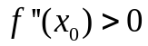 then f has relative …………. At

► Minima
► Maxima
► None of these

Question No: 2 ( Marks: 1 ) - Please choose one
If f is a twice differentiable function at a stationary point and 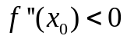 then f has relative …………. At

► Minima
► Maxima
► None of these

Question No: 3 ( Marks: 1 ) - Please choose one
A line 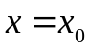 is called ------------ for the graph of a function 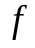 if 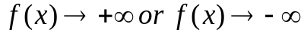 as approaches from the right or from the left

► Horizontal asymptotes
► None of these
► Vertical asymptotes

Question No: 4 ( Marks: 1 ) - Please choose one
If 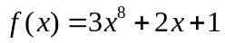 then 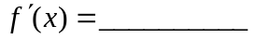
► 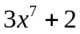

► 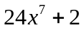
► 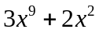
► 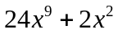

Question No: 5 ( Marks: 1 ) - Please choose one
If 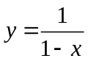 then 
► 1
► -1
► 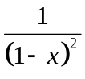
► 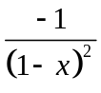

Question No: 6 ( Marks: 1 ) - Please choose one
If 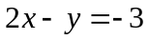 then
► 2
► -2
► 0
► -3

Question No: 7 ( Marks: 1 ) - Please choose one
If 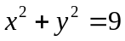 then
► 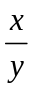
► 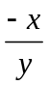
► 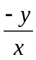
► 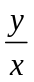

Question No: 8 ( Marks: 1 ) - Please choose one
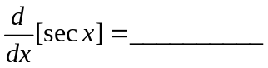

► 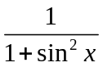
► 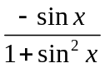
► 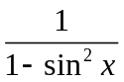
► 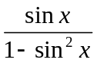

Question No: 9 ( Marks: 1 ) - Please choose one
30⁰ = ________

► 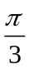
► 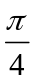
► 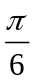

► 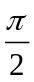

Question No: 10 ( Marks: 1 ) - Please choose one
Suppose that 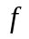and are differentiable functions of then
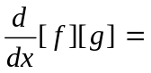

► 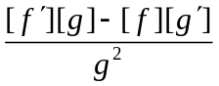
► 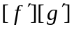
► 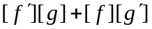-correct
► 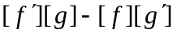

Question No: 11 ( Marks: 1 ) - Please choose one
Suppose that and are differentiable functions of then
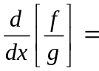
► 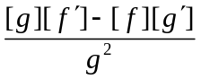
► 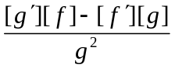
► 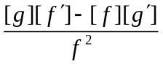
► 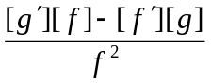

Question No: 12 ( Marks: 1 ) - Please choose one
If a function g is differentiable at a point x and a function f is differentiable at a point g(x), then the ________ is differentiable at point x .
► Composition (f o g)
► Quotient ( f / g )
► Product (f . g)
► Sum (f + g)

Question No: 13 ( Marks: 1 ) - Please choose one
Chain rule is a rule for differentiating ___________ of functions.
► Product
► Sum
► Difference
► Composition -correct

Question No: 14 ( Marks: 1 ) - Please choose one
The power rule, 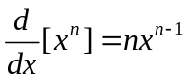 holds if n is __________
► An integer
► A rational number
► An irrational number
► All of the above

Question No: 15 ( Marks: 1 ) - Please choose one
Let a function be defined on an interval, and let  and 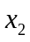 denote points in that interval. If 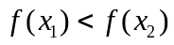 whenever 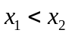 then which of the following statement is correct?
► is an increasing function.
► is a decreasing function.
► is a constant function.

Question No: 16 ( Marks: 1 ) - Please choose one
Let a function be defined on an interval, and let and denote points in that interval. If 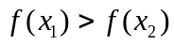 whenever then which of the following statement is correct?
► is an increasing function.
► is a decreasing function.
► is a constant function.

Question No: 17 ( Marks: 1 ) - Please choose one
If 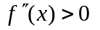on an open interval (a,b), then which of the following statement is correct?
► is concave up on (a, b) -correct
► is concave down on (a, b).
► is linear on (a, b).

Question No: 18 ( Marks: 1 ) - Please choose one
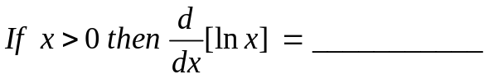
► 1
►
► 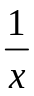
► 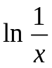

Question No: 19 ( Marks: 1 ) - Please choose one
Let 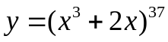. Which of the following is correct?
► 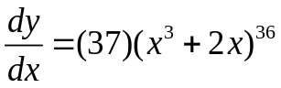
► 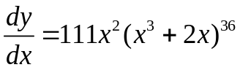
► 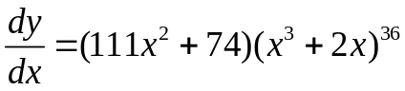
► 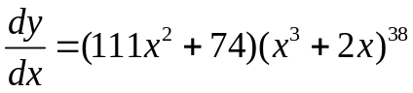

Question No: 20 ( Marks: 1 ) - Please choose one
What is the base of natural logarithm?

► 2.71
► 10

► 5
► Any real number

Question No: 21 ( Marks: 1 ) - Please choose one
If we have  then 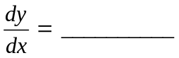

►
► 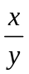
► 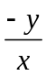
► None of these

Question No: 22 ( Marks: 1 ) - Please choose one
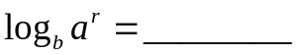

► 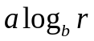
► 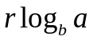 -correct
► 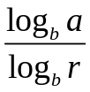
► 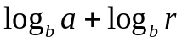

Question No: 23 ( Marks: 1 ) - Please choose one
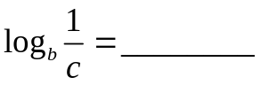

► 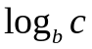
► 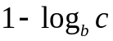
► 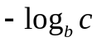
► 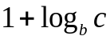

Question No: 24 ( Marks: 1 ) - Please choose one
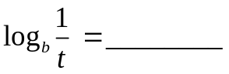

► 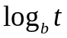
► 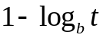
► 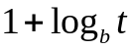
► 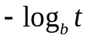 -correct

Question No: 25 ( Marks: 3 )
Differentiate: 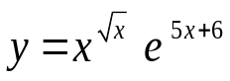

Question No: 26 ( Marks: 5 )
Differentiate 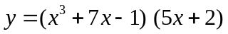

Question No: 27 ( Marks: 10 )
The derivative of a continuous function is given .Find all critical points and determine whether a relative maximum, relative minimum or neither occur there


